Trustee / Local Governor 
Application Form
Please note: This application should be completed, signed and dated and then returned to the Youth Engagement Schools Trust. Please write only within the text boxes. If needed, continue on a separate sheet of paper and attach it to this document. References may be contacted if applications are successful. On appointment as a Trustee/Governor a Disclosure and Barring Service (DBS) check will be undertaken.
Name:
- Please select if you are applying to be an Academy Governor ☐
Academy you wish to be considered for as a Governor:
- Please select if you are applying to be a Trustee on the Trust Board ☐
Please tell us how you became aware of this vacancy:

For trustee applications: Please return the completed application form to the Senior Governance Officer: Ilona Adu-Gyamfi; Email: i.adu-gyamfi@theyestrust.org
Post: Governance Officer, The YES Trust, Office 27, Riverside, Congleton CW12 1DY
For Academy Governor applications: Please return to your School Business Manager.
Background
Who are we?
Youth Engagement Schools Trust (YES Trust) is a small but growing multi-academy trust in the North West and currently comprises The Fermain Academy, The Axis Academy, The Keystone Academy, Cornerstone AP, The Raise Academy, The Vireo Academy and The Kairos Academy. We specialise in Special Needs and Alternative Provision, providing a vital service for some of the most vulnerable young people in the area. Our vision is to develop a thriving partnership of schools that work together to generate and celebrate success and to create opportunities for our students and staff that raise aspirations and inspire excellence. Further information about the YES Trust can be found on our website at http://www.theyestrust.org.
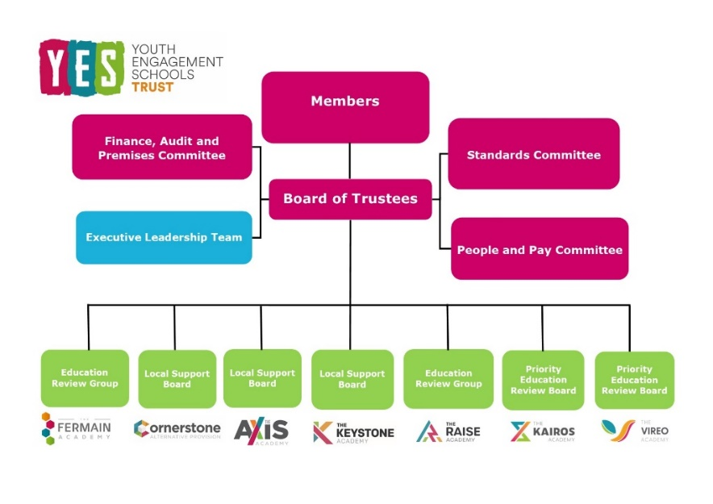

What do our Trustees do?
Trustees are responsible for holding the Trust’s executive leadership to account, offering scrutiny and challenge, and ensuring both robust governance and decision-making and an ability to balance what is important for pupils versus finances, achievement rates and delivering high-quality education to our future workforce. Trustees bring:
- Critical challenge without confrontation
- Support for one another
- Openness and honesty
- Structured feedback - upwards and downwards
- A differing perspective - a fresh pair of eyes and ears
- A sounding board
- Rational and constructive thinking without being emotive to the subject.
What do our Local Academy Governors do?
Local Governors are working with Headteachers and staff to ensure pupils get the best from their time in our academies. Their role is a strategic one to:
• Ensure clarity of vision, ethos and strategic direction;
• Hold the Headteacher to account for the educational performance of the organisation and its students, and the performance management of staff;
• Oversee the financial performance of the school making sure its money is well spent.
Who can become a Trustee/Governor?
We encourage applications from people from all walks of life so that we can draw on a wide variety of skills and experience to support and develop our Trust and academies. At the foot of this form is a list of eligibility criteria, but equally important is your readiness to work as part of a team that understands the Trust’s/academy’s work and ability to think through new ideas and decide what is best for the academy. This will mean you are willing to:
• Attend meetings regularly
• Become involved and get to know the Trust/academy
• Help the local community and increase the learning opportunities of the pupils
• Read all paperwork circulated for meetings
• Attend events at the Trust/academy
• Respect confidentiality at all times
What are the benefits of becoming a Trustee/Governor?
Trustees and Governors in the YES Trust will find the role challenging, interesting and deeply rewarding because they can see how their work contributes to the well-being and prospects of pupils, academies and communities. It gives them a real opportunity to make a difference. In addition, our Trustees and Governors tell us how it assists their personal development as being a Trustee/Governor provides experience of executive decision making.

More Information
For more information please follow the links below to:
The Fermain Academy: https://www.thefermainacademy.org/
The Axis Academy: http://www.theaxisacademy.org
Cornerstone AP: https://www.cornerstoneap.org
The Keystone Academy: https://thekeystoneacademy.org/
The Raise Academy: https://theraiseacademy.org/
The Black Country Alternative Provision: https://blackcountryap.org/
YES Trust: http://www.theyestrust.org

Personal details
Title: Forename(s): Surname:
Former name:
Date of birth:
Male Female
Address:

Email address:
Telephone (home): Telephone (work): Telephone (mobile):
Present job title:
Present employer:

Why do you want to become a Trust Board Trustee/Academy Governor?

Are you currently, or have you been, a Governor at another establishment?
Yes ☐ No ☐
If ‘yes’ please provide details:

Have you ever been removed from membership of a Governing Body or Board of Directors for any reason?
Yes ☐ No ☐
If ‘yes’ please provide details of the establishment and the reason for your removal:

Do you have any criminal convictions?
Yes ☐ No ☐
If ‘yes’ please provide details:

Is there anything in your personal or professional life that may bring Youth Engagement Schools Trust or the Academy into disrepute?
Yes ☐ No ☐
If so please provide details:

The following skills audit enables a Governing Body to explore its skills and knowledge base and use the information to organise committees, delegate tasks and assist in identifying any skill gaps for recruitment and training purposes. Do you have any of the following skills or experience? (place a X if applicable)
☐ ICT knowledge
☐ Legal knowledge
☐ Local knowledge
☐ Marketing/PR
☐ Premises maintenance
☐ Procurement/contracting services
☐ Project management
☐ Business – strategy and leadership
☐ Data analysis
☐ Education – attainment, progress, etc
☐ Financial planning
☐ Governance
☐ Health and safety
☐ Human Resources

Are there any other skills or experience you have gained that you could bring to the Trust/academy?

Are you, or have you been:
A parent or carer of a child in a YES Trust academy? Yes ☐ No ☐

If ‘yes’ please provide details:

An employee of a YES Trust academy? Yes ☐ No ☐
If ‘yes’ please provide details:

A contractor or supplier to a YES Trust academy? Yes ☐ No ☐
If ‘yes’ please provide details:

References
Please provide the details of two referees, please note these people cannot be related to you, your spouse or civil partner.
Reference One:
Name:
Address:
Email address: Telephone:
Capacity in which they know you:

Reference Two:
Name:
Address:
Email address: Telephone:
Capacity in which they know you:

Declaration of eligibility to become a YES Trust Trustee/Academy Governor
Please put an ‘X’ in the boxes that apply to you:
☐ I am aged 18 or over.

☐ I do not already hold governorship of the same academy. Please note that if you are applying for reappointment, this information relates to the period when your current term of office ends.
☐ I am not liable to be detained under the Mental Health Act 1983.
☐ I am not a bankrupt or subject to a disqualification order under the Company Directors Disqualification Act 1986 or to an order made under section 429(2)(b) of the Insolvency Act 1986.
☐ I have not been removed from the office of a charity trustee or trustee for a charity by an order made by the Charity Commissioners or the High court on the grounds of any misconduct or mismanagement or, under section 7 of the Law Reform (Miscellaneous provisions) (Scotland) Act 1990, from being concerned in the management or control of any body.
☐ I am not included on the barred list the list of teachers and workers with children or young persons whose employment is prohibited or restricted.
☐ I am not disqualified from being the proprietor of any independent school or from being a teacher or other employee in a school.
☐ I have not, in the five years prior to applying to be a governor, received a sentence of imprisonment, suspended or otherwise, for a minimum of three months without the option of a fine.
☐ I have not, in the twenty years prior to applying to be a governor, been previously convicted of any offence and had passed on me a sentence of imprisonment for a minimum of two and a half years.
☐ I have not, at any time, had passed on me a sentence of imprisonment for a minimum of five years.
☐ I have not, in the five years prior to applying to become a governor, been fined for causing a nuisance or disturbance on education premises.
☐ I am not subject to a disqualification order under the Criminal Justice and Court Services Act 2000.
☐ My estate has not been sequestrated.
☐ I am not the subject of a bankruptcy restrictions order or an interim order.
Signed:

Name:
Date:

